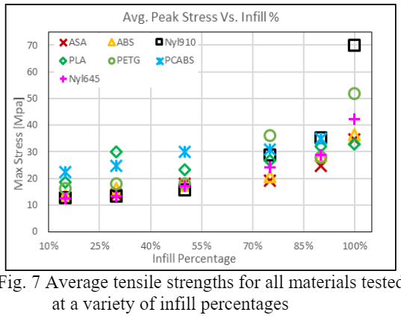

<https://ojs.imeti.org/index.php/AITI/article/view/1010/576>

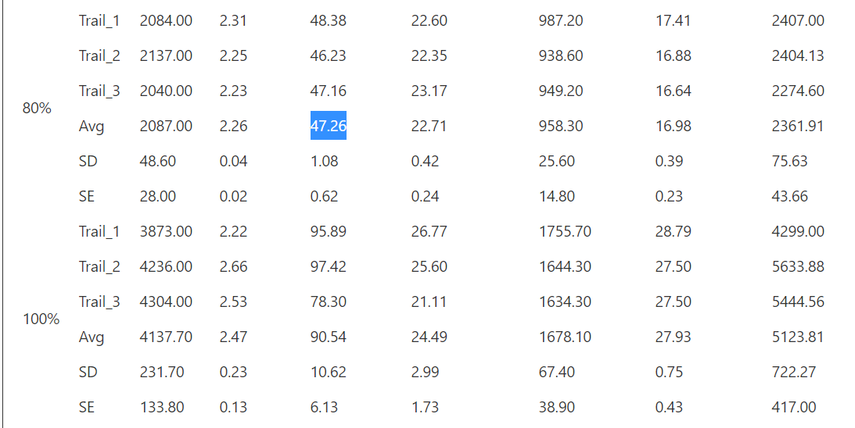

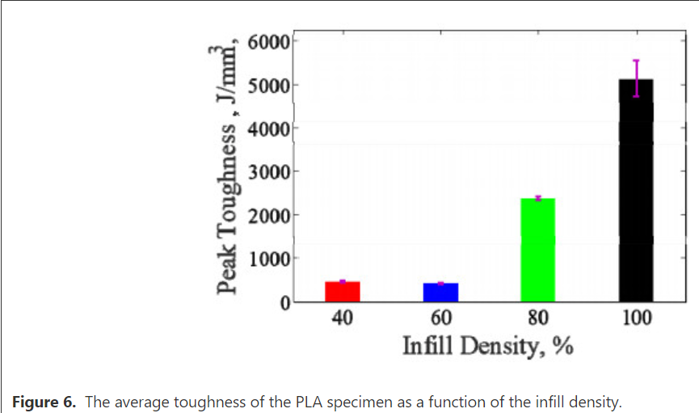

<https://www.aimspress.com/article/10.3934/matersci.2019.6.1033/fulltext.html>

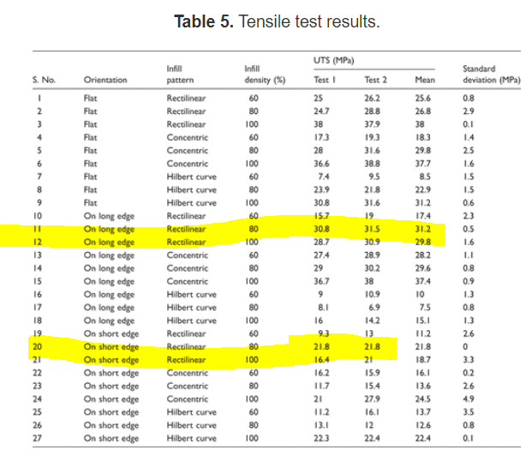

“In the case of 80% infill density, result shows ductile behaviour. This may be due to the fact that there is a minor air gap between the beads and during tensile loading some beads filled this gap. Thus it gave more elongation as compared to specimen built with 100% infill density.”

<https://journals.sagepub.com/doi/full/10.1177/0954406219856383>